Kingdom of Saudi Arabia

Ministry of Education

Imam Abdulrahman bin Faisal

University

Computer Science department

College of Science and Humanities

Database Concepts & Design

Project: Interactive room System

Shahad Emad Aljiaan - 2200003861

**Instructors:**

Dr.Thowiba Awad L. Samirah Albalhareth TA. Maha Alghamdi

Academic year 1443 – 2022

**1.0 Introduction**

In our project, we aim on designing a database using MySQL workbench for an interactive halls system that’s work on providing reservation service for the available halls in the system by filling the required information from the user to be updated for choosing the preferable date and time beside the nature of the reservation. The system owner will have the authority to perform many processes such as, adding, deleting, and updating the database. The user of the system will be asked to insert the required information and after that will be upgraded to be able to make a reservation for a certain hall. The reservation can be for the entire hall or part of it.

## **2.0 Functionalities**

- Maintenance of the reservation details inside the database which prevent it from being lost.

- Support the scalability and flexibility of the database since it will handle many modifying processes.

- the relationships between the database felids will improve the efficiency and will facilitate the retrieving prosses from the database.

### **3.0 Entity Relationship Diagram**

Discerption

#### **4.0 Schema**

##### **5.0 Tables**

create database InteractiveRooms;

use InteractiveRooms;

create table Manager (

mangerId numeric(10) not null,

mang_firstName varchar(10) not null,

mang_middleName varchar(10) not null,

mang_lastName varchar(10) not null,

email varchar(25),

maangerPassword varchar(10) not null,

primary key (mangerId));

create table InteractiveRooms (

RoomId numeric(10) not null,

SectionName1 varchar(35) ,

SectionName2 varchar(35) ,

SectionName3 varchar(35) ,

SectionCapacity1 numeric(5) ,

SectionCapacity2 numeric(5) ,

SectionCapacity3 numeric(5) ,

RoomCapacity numeric(5) ,

ManagerId numeric(10),

primary key (RoomId)

);

create table InteractiveRoomName (

roomname_NUM numeric(10) not null,

room_Id numeric(10),

RoomName varchar(35) not null,

primary key (roomname_NUM));

create table Users (

userId numeric(10) not null,

user_firstName varchar(10) not null,

user_middleName varchar(10) not null,

user_lastName varchar(10) not null,

email varchar(25),

userPassword varchar(10),

Birthdate date,

primary key(userId));

create table UserJob (

user_Id numeric(10) not null,

jobTitle varchar(25) not null,

primary key(user_Id));

create table Appointment(

appointmentId numeric(10),

appointmentDate date not null,

userId numeric(10),

primary key(appointmentId));

create table Timeslot (

SlotNumber numeric(10) not null,

Hours time not null,

appointment_Id numeric(10) ,

Booking_status boolean default false,

primary key(SlotNumber));

create table creatAppointment (

appointNumb serial NOT NULL,

appointment_Id numeric(10),

room_Id numeric(10),

primary key(appointNumb)

);

alter table InteractiveRooms

add constraint Fk_Mid

foreign key (managerID) references Manager (mangerId) on delete set null;

alter table InteractiveRoomName

add constraint roomid

foreign key (room_Id) references InteractiveRooms(RoomId) on delete set null;

alter table UserJob

add constraint Fk_useId

foreign key (user_Id ) references Users(userId);

alter table Timeslot

add constraint Fk_timeS

foreign key (appointment_Id) references Appointment (appointmentId) on delete CASCADE;

alter table creatAppointment

add constraint Fk_app

foreign key (Appointment_Id) references Appointment (appointmentId) on delete set null;

alter table creatAppointment

add constraint Fk_ap

foreign key (room_Id) references InteractiveRooms (roomId) on delete set null;

###### **6.0 Data in table**

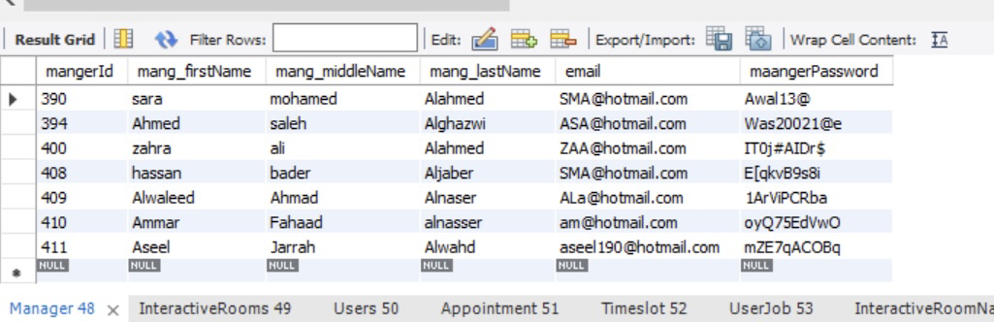-Manager table

- InteractiveRooms table

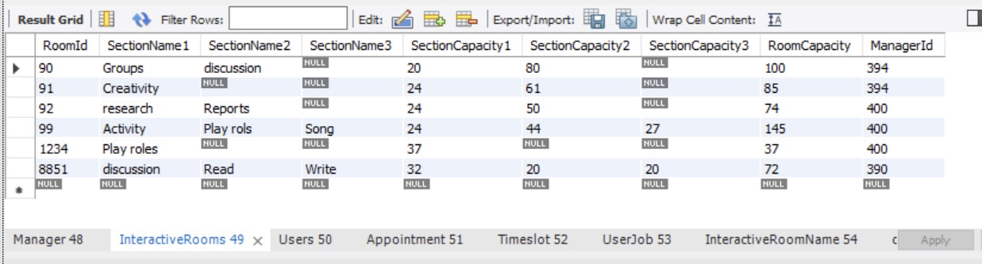

- InteractiveRoomName table

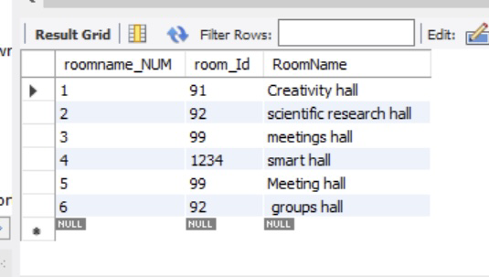

- Users table

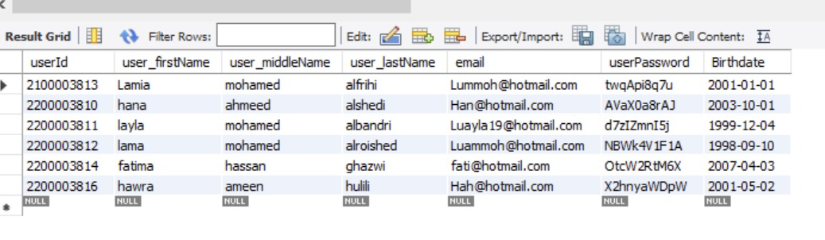

- UserJob table

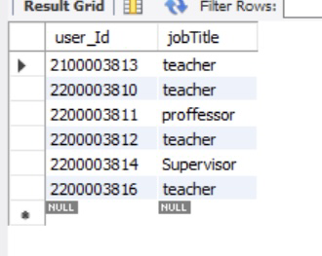

- Appointment table

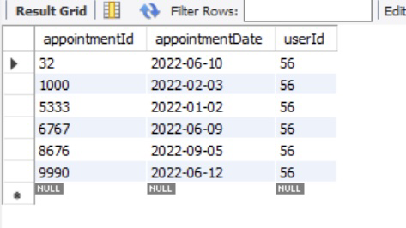

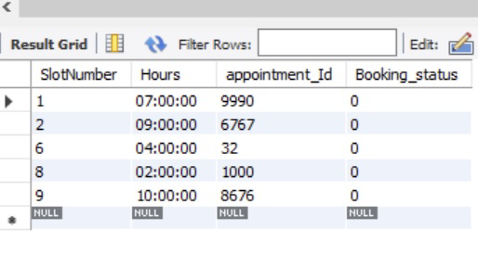- Timeslot table

- creatAppointment table

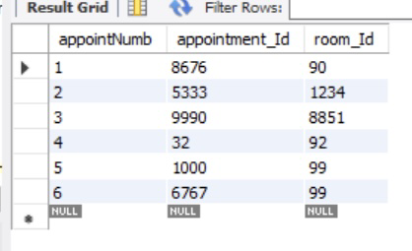

**7.0 Advanced Quires**

- Union

- Intersect

- Distinct

-  aggregate functions

sum

Min

-in

-between

-isNull

-like

-not like



